Original Research Paper- Medical Science
Oral Health awareness and Practice among Diabetic Patients in Diabetic center of Aljabal Al akhdar.
Corresponding Author: Halima A Ayyad
Community and Preventive Department, Faculty of Dentistry, University of Benghazi, Benghazi.
Article Received 25-08-2022 , Article Revised 10-09-2022 , Article Accepted 25-09-2022
ABSTRACT:
According to the International Diabetes Federation (IDF), more than 34.6 million people in the Middle East and North Africa Regions have diabetes. In Libya 2009 according to stepwise prevalence of diabetes was 16.4.The role of health professional is very important in improving the knowledge and practices regarding oral health care.. The aim of our study was to determine diabetic patients’ level of knowledge, awareness and practice about oral health and foot care. Subjects and methods; All diabetic cases attended in diabetic center of Aljabal Al akhdar. Albyada LIBYA during the year 2019 were included in the study. Cross section study design was applied using a structured questionnaire which included data related to personal characteristics and assessment of KAP of participants. Results: The highest proportion of cases (53.2%) their age ranged from 50-59 years. Nearly 59% were females. The mean duration of DM was 13.19± 7.92 years. Knowledge of participants about oral complication was low compared to systemic complication. Less than half of diabetic cases brushed their teeth, and eighteen percent used tooth floss. Only two percent of diabetics received their knowledge about diabetes from dentists. Recommendation There is a need that all health professional including dentists should play an important role in educating diabetics about diabetes and related complications.
Keywords: diabetic cases, oral health care, periodontal diseases, foot care, diabetes complications

INTRODUCTION:
Complications of Diabetes mellitus (DM) had been associated with many pathological mechanisms. The activation of the sorbitol pathway, the formation of advanced glycation end-products (AGEs), the damaging effect of oxidative stress and altered lipid metabolism are examples of these mechanisms. DM complications include; retinopathy, nephropathy, neuropathy, macrovascular disease and poor wound healing, all of them can lead to chronic morbidities and mortality⁽¹⁾ . According to the International Diabetes Federation (IDF), more than 34.6 million people in the Middle East and North Africa Regions have diabetes. In Libya 2009 according to stepwise prevalence of diabetes was 16.4% ^{(2, 3)} . A number of oral disorders have been associated with diabetes mellitus ⁽⁴⁾ . The association between diabetes and periodontal diseases has been recognized in the dental literature for many decades ^{(5, 6)} . Periodontitis has been considered as the sixth complication of diabetes ⁽⁷⁾ . It is well-established that diabetes increases the prevalence, severity, and progression of periodontal disease ⁽⁸). It was also proved that periodontal diseases may complicate the severity of diabetes by worsening the degree of glycemic control ⁽⁹⁾. periodontal disease is a chronic low-grade infection induced by multiple pathogens and can result in alteration of insulin action ⁽¹⁰⁾. Chronic gram-negative periodontal infection is thought to increase insulin resistance, contributing to the development of metabolic imbalance ⁽¹¹⁾ . also, uncontrolled or poorly controlled diabetes increases susceptibility to oral opportunistic infections (e.g., oral candidiasis) and contributes to xerostomia, which can lead to caries, soreness, ulcers, and infections in the mouth ⁽¹²⁾ . The treatment guideline produced by the Centre of Disease Control and Prevention (CDC) recommends dental care for diabetics patients at least once in every 6 months ⁽¹³⁾. The American Diabetes Association’s (ADA) standard for treating diabetic patients include examination of the oral cavity as part of the patient’s initial visit; however, unlike examinations of the eyes and feet, periodic oral examinations are not included as a standard of continuing car ⁽¹⁴⁾ diabetic patients’ awareness of their increased risk for oral diseases was low compared to their awareness of systemic diseases and a significant association was found between glycemic control and oral infections⁽¹⁶⁾ . diabetics will be encouraged to self-care of themselves leading to proper glycemic control and decreasing all the complications of diabetes. The overall result will be reduction of diabetes burden on the health care system as a whole ⁽¹⁷⁾ . The aim of our study was to determine diabetic patients’ level of awareness and practice about oral health
SUBJECTS AND METHODS:
All diabetic cases attended Diabetic center of Aljabal al Alkhdar during the period of study (6 months) - year 2019 were included in the study. The cross section study design which is a descriptive study was applied using a structured self-administered questionnaire. The first section is concerned with personal characteristics such as; age, gender, education and occupation. The Second section explored the level of knowledge and awareness of diabetic patients about diabetes and related oral health complications as well as their self-reported practices regarding oral health care. The third section, diabetic patients were asked about their sources of information regarding oral, and their suggestions to improve their knowledge about diabetes and its effect on oral health. the questionnaires were distributed. The verbal consents of participants were taken after explaining the purpose of the study and assuring them that anonymous to gain participants' trust and confidence as well as to encourage them to share information. Statistical analysis of data was done by using SPSS for Windows, version 25.0 (SPSS Inc., Chicago, USA) . Descriptive statistics were calculated as mean, median, mode, and standard deviation for quantitative variables as duration of diabetes and level of fasting blood sugar. Frequencies and percentages were used for the qualitative variables
RESULTS:
A total of 111 diabetic patients filled in the questionnaires. Nearly 59% were females and 41 % were males (Figure 1). Most of the participants were Libyans (95.50%). The mean duration of DM was 13.19 ± 7.92 years and their mean fasting blood sugar level was197.25 ± 77.74 mg/dl (Table 1). More than half (53.15%) did not know the type of diabetes they had, 30.63% knew that they had Type 2 diabetes and 16.22% knew that they had Type 1 (Figure 2)
knowledge and awareness of systemic complications associated with diabetes, most of the cases (94.6%) were aware of their increased risk for visual complications, followed by 80.2% for those who knew the cardiac complications; gingival disease was 71.2%, an oral fungal infection was 61.2% and dental caries was 57.7%, while nearly one third (32.4%) had no knowledge that dental caries is common among diabetic cases (Table2). When cases were asked about their knowledge related to symptoms of gingivitis among diabetic patients, majority of them (72.1%) were aware that redness and swelling are signs of gingival disease, 45.9% were aware that halitosis of the gingiva is a sign of gingivitis. Lesser proportion of cases (42.3 %, 40.5% and 36% respectively) knew that mobility of the teeth, bleeding of the gingiva and sore mouth are signs of gingivitis. Whereas, equal proportions (18%) had no knowledge that mobility of the teeth and sore mouth are symptoms of gingivitis . Less than three quarters (73.9%) of patients suffered sometimes of dry mouth, while (9.9%) of participants were always suffering from dry mouth (Table4). More than half (56.8%) of the respondents did not brush teeth and majority of cases (82%) never used dental floss and who were using dental floss represented only 18% . 42.5% brushed once a day, 36.1% were brushing twice a day and 21.2% were irregularly brushing their teeth. Quarter (25%) of the patients who were using dental floss reported using it once a day and 40% used it many times per day (Table 5). During last year, less than half (45.9%) of cases did not visit dental clinic, 51.4% reported that they visited dental clinic when needed only and few (2.7%) of cases visited dental clinic twice a year (Table 6). The majority (70.3%) of patients stated that they need more knowledge. The sources preferred by diabetic patients to gain more knowledge were diabetologists (60.4%), mass media (15.3%), health education (4.5%), schools (2.7%) and dentists (1.8%) (Table7).
DISCUSSION:
The greatest increase in prevalence of DM is occurring in developing countries. It was declared by WHO that 366 million people are expected to suffer from diabetes mellitus by 2030 ⁽¹⁸⁾ . The present study assessed awareness and practice of diabetic patients about oral health care in diabetic center, AL-Bayda-Libya, using a structured self-administered questionnaire. Thirty percent of participants had Type 2 diabetes, 16.22% suffered from Type 1 and, unexpectedly, more than half (53.15%) of participants did not know which type of diabetes they had. On the other hand, El-Khawaga G & Abdel-Wahab F conducted a study in Egypt, revealed that 93.1% of the participants had type 2 and 6.9 had type 1 ⁽¹⁹⁾ . A considerable percentage of diabetic patients’ demonstrated adequate knowledge and awareness of systemic complications associated with diabetes. Most of the cases (94.6%) were aware of their increased risk for visual complications, followed by 80.2% for those who knew the cardiac complications. While, their awareness about oral complications associated with DM was lower as; gingival disease was 71.2%, an oral fungal infection was 61.2% and dental caries was 57.7% and nearly one third (32.4%) had no knowledge that dental caries is common among diabetic cases. These findings are consistent with Allen et al, who found out that the participants’ knowledge was much higher about systemic complications than about oral complications⁽²⁰⁾ . On the contrary to our findings a study on diabetic cases in Dhaka-India, reported that higher proportion (62.6%) of patients had more score of knowledge about oral disease than foot and visual complication (37.2% and 18.3%) respectively ⁽²¹⁾ . Majority of (72.1%) diabetic patients in the present study were aware that redness and swelling are signs of gingival disease, 40.5% of diabetic patients were aware that bleeds during brushing is a sign of gingival disease, and 36% were aware that soreness of the gingiva is a sign of periodontal disease. This level of knowledge was higher compared to another study randomly selected sample of 500 diabetic patients was recruited from three hospitals and three comprehensive health centers that represent both urban and rural populations in Jordan ⁽¹⁵⁾ . This study also revealed an important finding that more than 70% of the participants were suffering from dry mouth. This finding is consistent with a systemic review of over fifty studies conducted by Pintor et al on prevalence rates of xerostomia in the DM and non-DM population, which reported that there is a higher prevalence of xerostomia (dry mouth) and lower salivary flow rates among Diabetes mellitus patients ⁽²²⁾ . Regarding oral self-care practices, 42.3% of participants brushed their teeth, and 82% never used dental floss to clean between their teeth. Similar results were reported in study among diabetic patients in Dubai, United Arab Emirates, where half of the participants brushed their teeth once and 66% never used dental floss ⁽¹⁶⁾ . The present results indicate a great need to focus on raising the awareness about oral self-care. The data of the present study showed that only 2.7% of the participants had visited a dental clinic two times per year, 51.4% visited a dental clinic only when they needed to receive treatment for pain and / or discomfort and 45.9% did not visit dentist. This finding is consistent with the result of a study which reported that only 14% of diabetic patients attending the outpatient diabetic clinic in United Arab Emirates visited regularly for dental check-ups ^{(16).} A survey done in the United Kingdom by Allen revealed higher percentage of diabetics was visiting dentists compared to our cases ⁽²⁰⁾ . In addition, the majority of diabetic patients (70.3%) in the present study needed more knowledge and wished to receive information about diabetes counseling through diabetologist. This fact should alert the physician’s behavior and attitude which have positive effect on their patients care practice ⁽²¹⁾. On the other hand, some physician’s focus on acute management rather than preventive care due to heavy load of patients. Existing clinical evidence suggests that increasing community awareness regarding diabetes management is an ultimate tool for halting complications due to diabetes ^{(14, 15)} Limitations encountered by the investigator were many patients did not participate in the study as they had short time to spend in the clinic. Also the result of this study may not reflect the actual practices of the patients due to reliance on selfreporting of practices.
CONCLUSIONS AND RECOMMENDATIONS:
There is a need that all health professional including dentists should play an important role in educating diabetics about diabetes and related complications. Good communication between dentists and physicians will improve oral health which could influence the control of blood glucose level. Awareness of the potential associations between diabetes, oral health and general health needs to be increased in diabetic patients.

REFERENCES:
1. Stratton IM, Adler AI, Neil HA, Matthews DR, Manley SE, Cull CA, Hadden D, Turner RC, Holman RR on behalf of the UK Prospective Diabetes Study Group. Association of glycaemia with macrovascular and microvascular complications of type 2 diabetes (UKPDS 35): prospective observational study. BMJ 2000; 321(7258):405-12.
2. International Diabetes Federation, Middle East and North Africa. Libya. Available at: http://www.idf.org/membership/mena/libya. Cited on 2017 3. World Health Organization. Libya STEPS Survey 2009 Fact Sheet. Available: http://www.who.int/ncds/surveillance/steps/Libya_2009_STEPS_Fa ctSheet.pdf?ua=1. Cited on 2020
4. Kidambi S, Patel SB. Diabetes mellitus: Considerations for dentistry. J Am Dent Assoc. 2008; 139:8S–18S.
5. Lalla E, Cheng B, Lal S, Kaplan S, Softness B, Greenberg E, et al. Diabetes-related parameters and periodontal conditions in children. J Periodontal Res 2007; 42: 345–349.
6. Morita I, Inagaki K, Nakamura F, Noguchi T, Matsubara T, Yoshii S, et al. Relationship between periodontal status and levels of glycated hemoglobin. JDent Res 2012; 91(2):161–6 91.
7. Saini R, Saini S, Sugandha R. Periodontal disease: The sixth complication of diabetes. J Family Community Med. 2011; 18: 31.
8. Meenawat A, Punn K, Srivastava V, Meenawat AS, Dolas R. S., Govila V. Periodontal disease and type I diabetes mellitus: Associations with glycemic control and complications. J Indian Soc Periodontol. 2013; 17(5): 597– 600.
9. Donnahue R, Wu T. Insulin resistance and periodontal disease: An epidemiologic overview of research needs and future directions. Ann Periodontol. 2001;6:199 –224.
10. Brian L. Mealey, Periodontal disease and diabetes. A twoway street. JADA.2006; 137, 26-31
11. Genco R, Grossi SG, Ho A, Nishimura F, Murayama Y. A proposed model linking inflammation to obesity, diabetes and periodontal infection. J Periodontol. 2005; 76:2075–84.
12. Ship JA. Diabetes and oral health: an overview. JADA 2003; 134:4–10.
13. Centre for Disease Control and Prevention, Diabetes Public Health Resource. Take Charge of Your Diabetes. http://www.cdc.gov/diabetes/pubs/tcyd/dental.htm
14. American Diabetes Association: Standards of medical care for patients with diabetes mellitus (Position Statement). Diabetes Care 1999; 22:32 -41. 15. Al Habashneh R, Khader Y, Hammad MM, Almuradi M. Knowledge and awareness about diabetes and periodontal health among Jordanians. J Diabetes Complications. 2010; 24:409 -14.
16. Eldarrat A. Awareness and attitude of diabetic patients towards their increased risk for oral diseases. Oral Health Prev Dent 2011; 93: 235-241.
17. Dinesh PV, Kulkarni AG, and Gangadhar N K. Knowledge and self-care practices regarding diabetes among patients with Type 2 diabetes in Rural Sullia, Karnataka: A community-based. J F M P C 2016; 5(4): 847–852 20. 18. World Health Organization. Global Report on Diabetes. Geneva: World Health Organization; 2016. Available from: www.who.int/diabetes/global-report/en/. (Last accessed on 2018 Jan 7.
19. El-Khawaga G, Abdel-Wahab F. Knowledge, attitudes, practice and compliance of diabetic patients in Dakahlia, Egypt. European Journal of Research in Medical Sciences. 2015; 3 (1):40-50
20. Allen EM, Ziada HM, O’Halloran D, Clerehugh V, Allen PF. Attitudes, awareness and oral health-related quality of life in patients with diabetes. J Oral Rehabil. 2008; 35: 21823.
21. Rahaman KS, Majdzadeh R, Naieni KH, Raza O. Knowledge, Attitude and Practices (KAP) Regarding Chronic Complications of Diabetes among Patients with Type 2 Diabetes in Dhaka. Int J Endocrinol Metab. 2017 July; 15(3):e12555: 1- 13

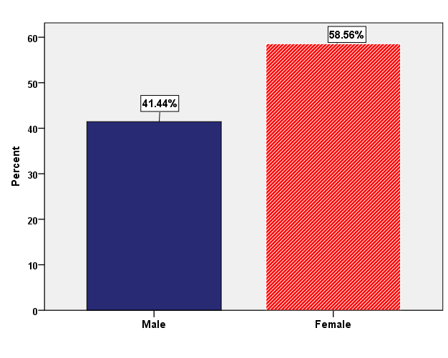

Figure 1: Distribution of diabetic cases according to their gender

Table 2: duration of diabetes and fasting blood sugar level among diabetic patients.
Variables | Mean (SD)
Duration of diabetes in years | 13.19 ± 7.92
Fasting blood sugar level of diabetic patients  No = 92 | 197.25 ± 77.74

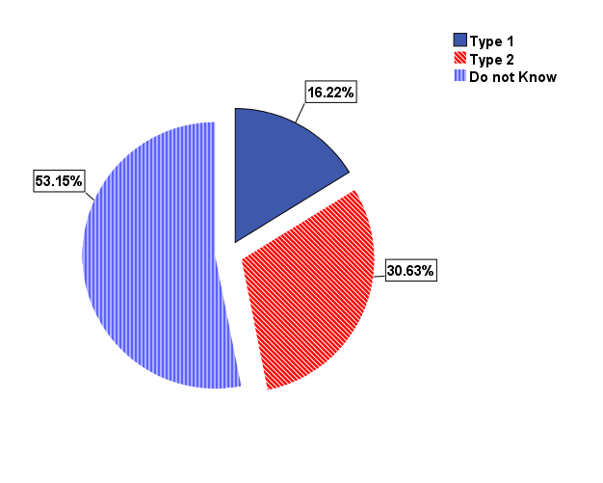
Figure 2: Participants’ knowledge of their diabetes type

Table 2: Distribution of diabetic patients regarding their knowledge about Diabetes complications.
Diabetes complications | Yes  % |  | No |  | Do not know
 | N | % | N | % | N | %
 | 8)
Visual | 105 | 94.6 | 4 | 3.6 | 2 | 1.8
cardiac complications | 89 | 80.2 | 14 | 12.6 | 8 | 7.2
foot complications | 83 | 74.8 | 22 | 19.8 | 6 | 5.4
gingival complications | 79 | 71.2 | 27 | 24.3 | 5 | 4.5
Dental caries | 64 | 57.7 | 11 | 9.9 | 36 | 32.4
Fungal infections | 68 | 61.3 | 37 | 33.3 | 6 | 5.4

Table 3: Knowledge of diabetic patients about symptoms of Periodontal disease among diabetic patients
Symptoms of gingivitis | Yes  % |  | No |  | Do not know
 | N | % | N | % | N | %
 | 8)
Redness & swelling | 80 | 72.1 | 17 | 15.3 | 13 | 11.7
Bleeds during brushing | 45 | 40.5 | 49 | 44.1 | 17 | 15.3
Sore | 40 | 36.0 | 51 | 45.9 | 20 | 18.0
Halitosis of the gingiva | 51 | 45.9 | 47 | 42.3 | 12 | 10.8
Mobility of the teeth | 47 | 42.3 | 44 | 39.6 | 20 | 18.0

Table 4: History of dry mouth among diabetic patients .
complain of dry mouth among diabetic patients | N | %
 | 8)
Always | 11 | 9.9
Sometimes | 82 | 73.9
No | 18 | 16.2
Total | 111 | 100.0

Table 5: Practice of diabetic patients regarding their oral hygiene care
Teeth care | Yes  %
 | N | %
 | 8)
Use of teeth brush | 47 | 42.3
Use dental floss | 20 | 18.0

Table 13: | 8)
For how many times use tooth brush | Once | 20 | 42.5
 | Twice | 17 | 36.1
 | Irregular | 10 | 21.2
For how many times use dental floss | Once | 5 | 25
 | Many times | 8 | 40
 | Sometimes | 7 | 35

Table 6: Frequency of visiting of diabetic patients dental clinic.
Frequency of dental clinic visit | N | %
 | 8)
Yes, two times per year | 3 | 2.7
No | 51 | 45.9
When needed | 57 | 51.4
Total | 111 | 100.0

